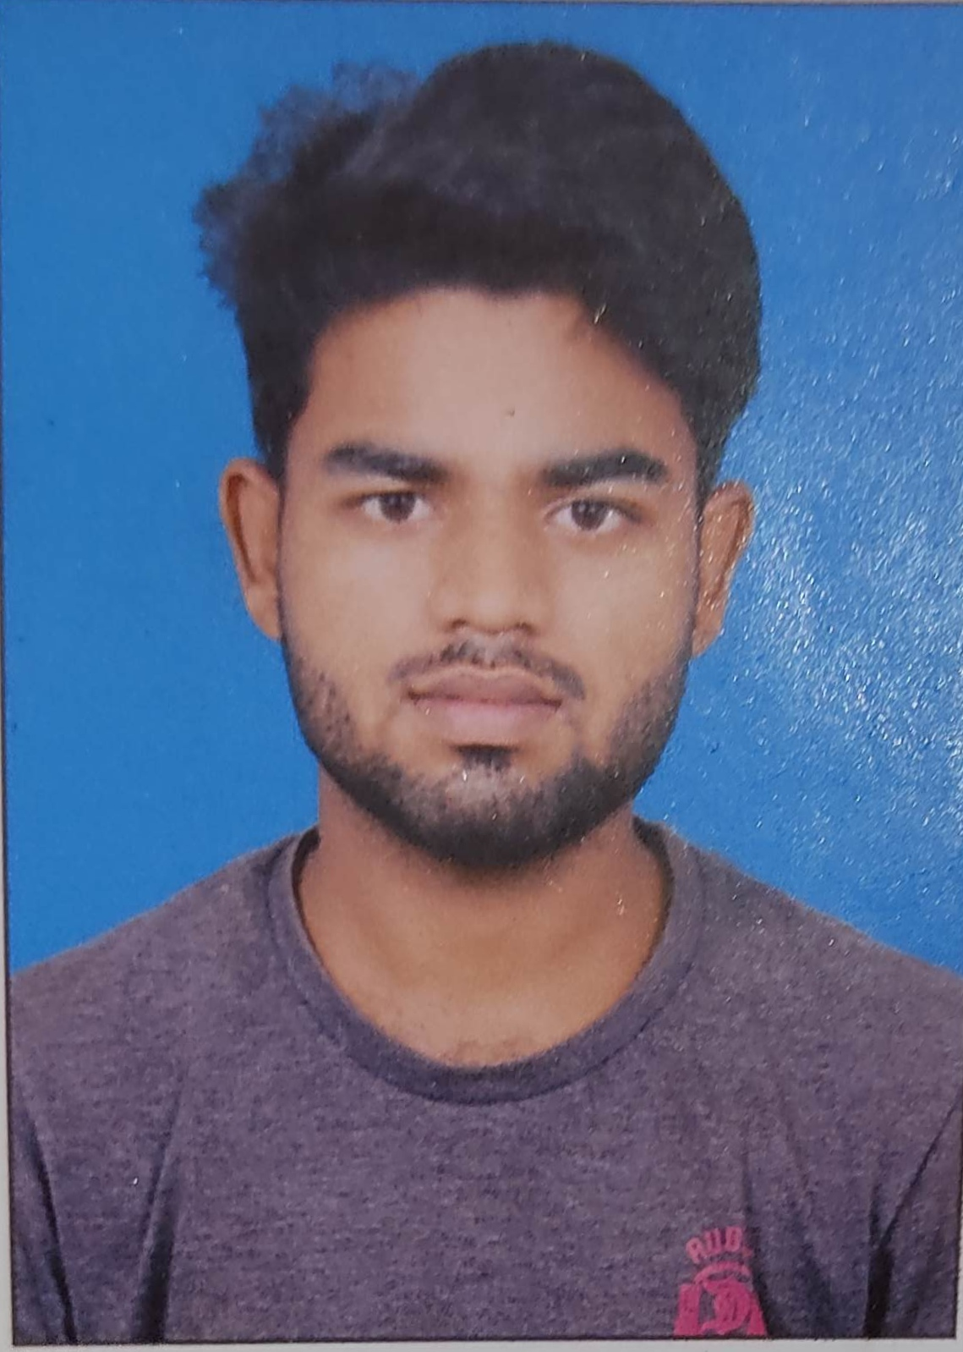

Primary Skill- **React Js, HTML, CSS, JavaScript , Bootstrap, Angular, Typescript**

Database- **MongoDB**

Version Control Software-**GitHub**

Project Tracking & Documentation- **JIRA**

Key Proficiency

* **2 Years of IT** experience in developing highly scalable enterprise application in **Html5**, **CSS, JavaScript**, **React Js** .
* As a frontend developer involved in developing Codes as per customer requirements and strictly following the model view controller architecture.
* Extensive knowledge in all stages of application development life cycle including software, requirement gathering , protoyping ,design, development, implementation ,performing testing & post production support .
* Implemented various screens for the frontend using React.Js and used various predefined components from NPM and redux library and also used some many useful library of react .
* Used **ag-Grid** for fetching Data from end points and displaying it in ag-grid table and then exporting those data in a Ms-Excel file with React Code.

Creative |Team player | Sincere I Flexibility

Strengths

Education

Bachelor of Technology (B. Tech) in Mechanical Engineering with 6.5 CGPA

**Surendra Parida**



Bhubaneswar, India

Surendraparida75@gmail.com

+91-7504418633

+91-7540875139

I am working with ENOSIS TECHNOLOGY in ENOSIS E-Commerce domain as an frontend developer. I have Two year of experience in development and enhancement of Web Application using **HTML**, **CSS, JavaScript,** and **React Js**. I experienced in **Agile** methodology also worked on **Iterative** and **Prototype** delivery models as well.  I have a good experience in working closely with cross functional teams during development. I have a remarkable experience in working closely with foreign clients to understand their requirements, analyzing them, developing the required module(s) and delivering them both single handedly and as part of a team.

Accomplishments

Professional Experience Summary